**Tazhibayev Sultanbay**

**SE-2326**

**Assignment 4**

**Advanced Operating Systems | Seilkhanova Kymbat**

# Objective

To explore how the operating system handles input/output devices by implementing four simple programs: word counting, file-based average score calculation, mouse interaction with Pygame, and speech recognition.

# Environment Setup

* **Host OS:** macOS
* **Guest OS:** Ubuntu (via Virtual Machine)
* **Python Version:** 3.12.x (inside a virtual environment)
* **Key Libraries:** Pygame, SpeechRecognition, PyAudio

# Exercise 1: Word Count

**Task:** Read a sentence from the user and display the total number of words entered.

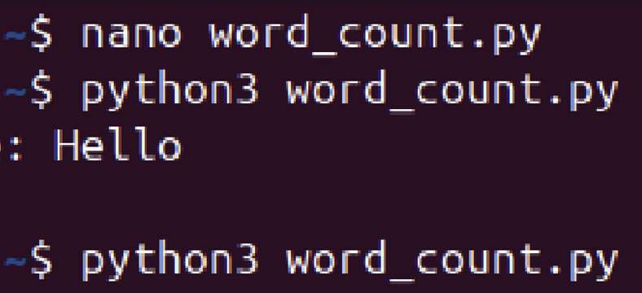

# Exercise 2: Average Score Calculation

**Task:** Read student names and scores from a text file and compute the average score with two decimal places.

**Data File:** students.txt containing student names and scores.

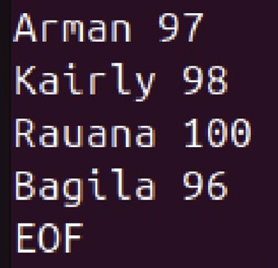

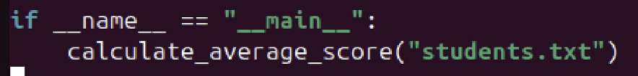

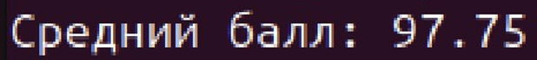

# Exercise 3: Mouse Interaction with Pygame

**Task:** Create a graphical window, then track and display mouse clicks and movements in the console.

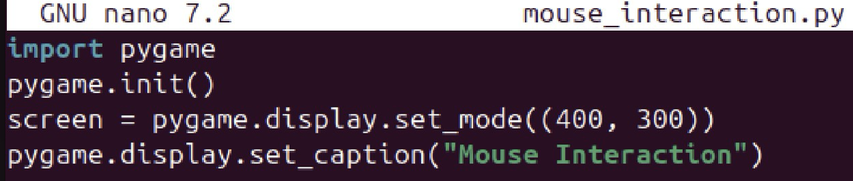

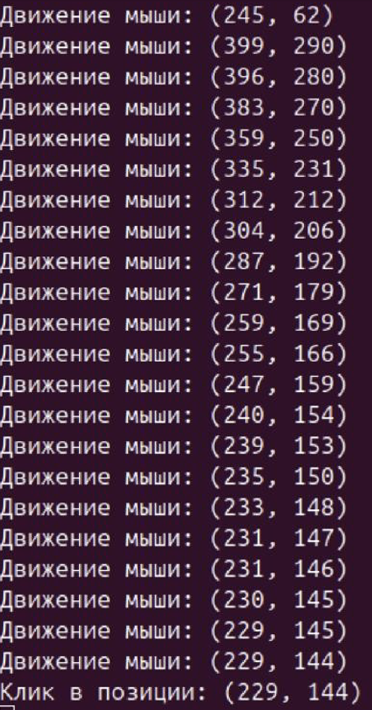

# Exercise 4: Speech Recognition

**Task:** Capture audio from the default microphone, send it to an online speech-to-text service, and display the recognized text.

1. **Hardware Check:** Confirm the system recognizes the microphone.
2. **Audio Test:** Record a short WAV file via the command line and play it back.
3. **Device Listing:** List available recording devices in Python and select the correct one.
4. **Recognition Test:** Run the speech-recognition program and verify the spoken phrase is correctly transcribed.

